**Verified Human footprint in a 250 m buffer around on grid and off grid Terrestrial Sites in Boreal region. Survey Year 2003 to 2016.**

* All_HF_buff250m_BorealRegion_2003_2016.csv

Results for the following definition of Boreal region:

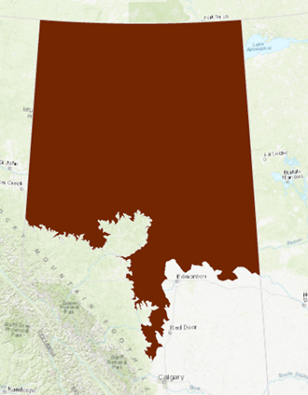

* All_HF_buff250m_OfficialNR_BorealRegion_2003_2016.csv

Results for the following definition of Boreal region:

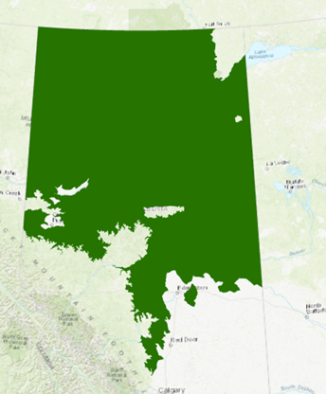

Result for 2017 and 2018 will be provided once the verified human footprint for these 2 years is done (early January).